
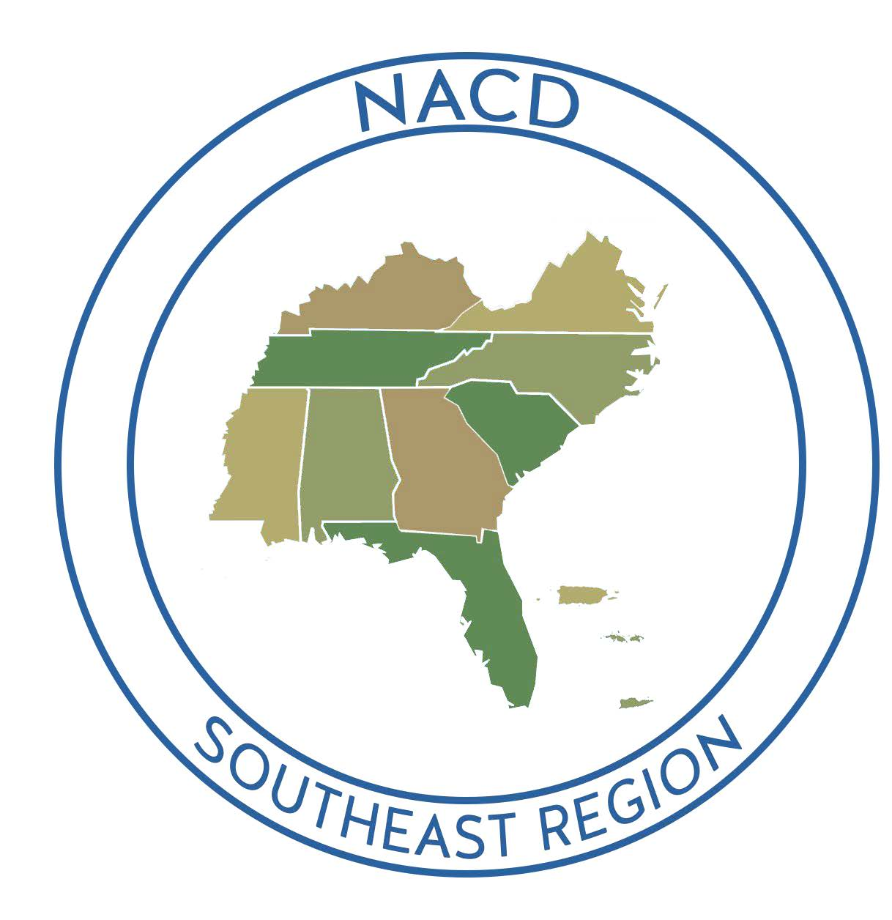
2025 NACD Southeast Regional Meeting
& KACD 81st Annual Meeting
August 2-6, 2025
Crowne Plaza Louisville Airport
Louisville, KY

Badge Name: ________ ____ District/Agency:

Street Address: City, State, Zip: _______

Phone Number: _______ Email:

Spouse Name (if attending): _______________

Check One: ( ) District Official, ( ) State Agency, ( ) NACD, ( ) District Employee, ( ) Auxiliary, ( ) NRCS, ( ) Youth Leader
Other: Title:
# of Tickets | Types of Tickets | Price | Amount
 | Registration Options for Kentucky & SENACD Attendees
 | NACD Southeast Meeting Full Pre-Registration  Includes admission to all SENACD & KACD Sessions, ONE ticket to Monday Morning Leadership Breakfast, ONE ticket to the Monday Evening Reception, ONE ticket to the SE Region Hall of Fame Luncheon, and ONE ticket to the Tuesday Evening Banquet. | $375.00
 | SPOUSE/GUEST NACD Southeast Meeting Pre-Registration  Includes ONE ticket to Monday Morning Leadership Breakfast, ONE ticket to the Monday Evening Reception, ONE ticket to the SE Region Hall of Fame Luncheon, and ONE ticket to the Tuesday Evening Banquet | $215.00
 | *Registration Options for Kentucky Attendees Only*
 | KACD 81st Annual Convention Full Pre-Registration  Includes admission to all KACD sessions, ONE ticket to the Monday Evening Reception, and ONE ticket to the Tuesday Evening Banquet. | $225.00
 | One Day Only KACD Registration  *Available for Monday or Tuesday Only* | $150.00
 | KENTUCKY YOUTH REGISTRATION  Youth Leadership Full Registration (Kentucky Youth Only)  Includes admission to all KACD sessions, ONE ticket to the Monday Evening Reception, and ONE ticket to the Tuesday Evening Banquet. | $100.00
ADDITIONAL TICKET INFORMATION
 | TOURS
 | *Available to Full Registration Ticket Holders Only*
 | Sunday Tour 1: Oldham Co Hermitage Farm & Yew Dell Botanical Gardens (Limit 110 People), 9am – 4pm | $75.00
 | Sunday Tour 2: Distillery & Horse Farm (Limit 110 People), 9am – 4pm | $75.00
 | Tuesday Afternoon: Louisville Slugger Museum & Factory (Limit 54 People) | $45.00
**Due to limited tickets, if submitting registration by paper form, it is recommended to contact KACD Executive Director, Crystal Renfro to confirm availability of tour tickets.
ADDITIONAL TICKET INFORMATION
ADD ON MEALS/BANQUET TICKETS
 | Kentucky Night Reception at the KY Derby Museum - Sunday, Aug 3 | $100.00
 | Additional KACD Awards Reception-Monday, Aug 4 | $45.00
 | Leadership Breakfast – Monday, Aug 4 | $40.00
 | NACD SE Hall of Fame Luncheon – Monday Aug 4 | $50.00
 | Kentucky RC&D Breakfast – Tuesday Aug 5 | $40.00
 | KACD Auxiliary Breakfast – Tuesday Aug 5 | $40.00
 | KACDE/SECDEA Luncheon – Tuesday Aug 5 | $50.00
 | Addt’l KACD 2025 Banquet Tickets – Tuesday, Aug 5 (before July 18) | $75.00
 | Addt’l KACD 2025 Banquet Tickets After July 18 and on site | $85.00
** Everyone is welcome to attend any of the meals/banquets with purchase of ticket **
 |  | Total:
Deadline for Pre-Registration is July 18, 2025 (Must be received by KACD by July 18, 2025)

Full refunds can be issued for advance payments only if cancellations are made by July 18, 2025. Requests can be sent to KACD Executive Director, Crystal Renfro at crystal.renfro.kacd@outlook.com .

Tickets for all meals & tours will be given to you when you
check-in at registration and will be required for access to all events.

FORM OF PAYMENT:
Check (payable to KACD) enclosed # _______________

Checks should be made payable to:
KACD (Kentucky Association of Conservation Districts)

Please return this form by:
Mail – KACD * P.O. Box 4027 * Frankfort, KY 40604-4027
or
Email – Crystal.Renfro.KACD@outlook.com


To Pay by Credit Card:
Please Complete Registration Online:
https://2025-kacd-annual-conference.cheddarup.com or



REGISTRATION FOR DISPLAY SPACE
(Conservation Districts: You must register for the Convention to hold a display space.)

- County or Company: __________________________________________________________________

- Name of Registration the display is connected with: __________________________________________

- Electricity Needed? ____________________________________________________________________

- Please be aware that you are responsible for all items within your display area.

- Display space for conservation districts is on a first come, first serve basis. Always send this request early. A paid registration must be received with request.

- All displays may be set up beginning at 12:00 PM, Sunday, August 3rd, and must be taken down by 3pm on Tuesday, August 5th.

- No booths will be reserved without this form submitted by the required cut-off registration date of July 18, 2025.

